**Asking Prices for Melbourne Houses up 13.3% On Year**

**Property Listings Record Surprise Fall in October**

**1 November, 2016**

Figures released today by SQM Research reveal residential asking property prices grew in most Australian cities in October, led by Melbourne and Hobart, with prices driven higher by low interest rates and a surprise fall in property listings.

Year-on-year results reveal Melbourne median asking prices have jumped 13.3% for houses to $792,000 and 5.4% for units to $458,200. Hobart median asking prices for units climbed 21.7% from a year earlier and house prices are up 9.8%.

While Sydney median asking house prices are up to $1,165,100, vendors for now appear to have been willing sellers at these levels and have not pushed harder. Prices in Darwin and Perth are still falling, with the median asking price for a house in Perth at $682,800, 5.2% lower than this time last year, and $620,900 in Darwin, down 6.6% from a year earlier.

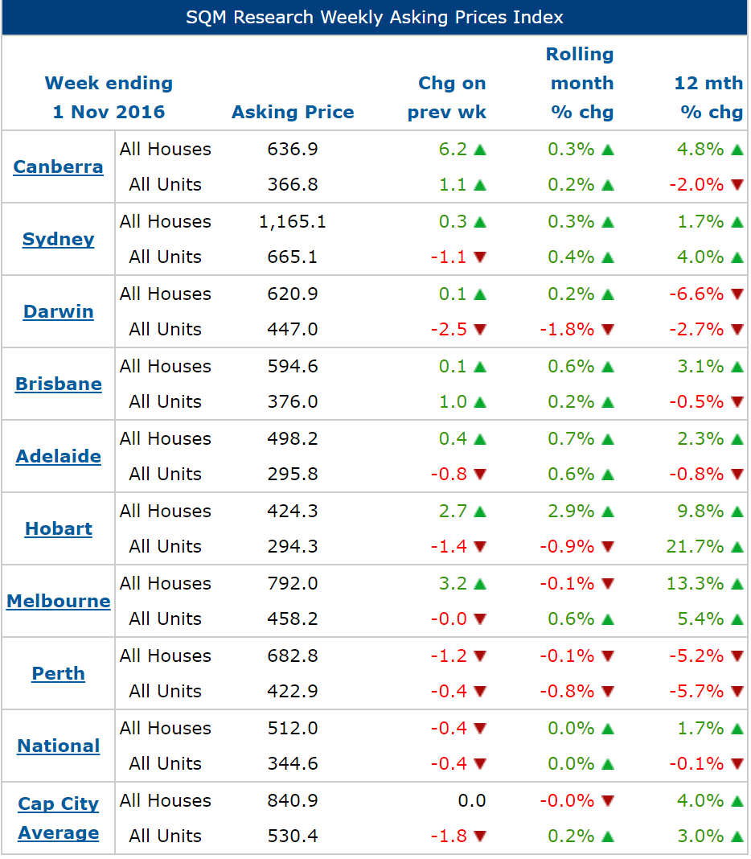

Source: [www.sqmresearch.com.au](http://www.sqmresearch.com.au)

Meanwhile, the number of Australian residential property sale listings fell in most capital cities during the month of October 2016, led by declines in Melbourne, with only Canberra and Perth reporting rises, figures released today by SQM Research reveal. The number of national residential property listings fell 2.1% in October to 339,922 new listings, to be down 6.5% from a year earlier.

Notably, Sydney property listings fell 1.4% in October, to be down 7.3% from one year ago, reflecting a lack of supply which is keeping upward pressure on property prices. In Melbourne, listings are down 10.4% from a year ago, while they are down 18.2% in Hobart, again pressuring housing prices higher.

“The shortage of properties for sale in Melbourne and Hobart is creating upward pressure on property asking prices, while growth in asking prices has cooled slightly in Sydney. Quite frankly to see listings fall during what is normally a month that records seasonal surges, is a concern to me,” said Louis Christopher, the Managing Director of SQM Research.



Elsewhere, Brisbane recorded a monthly fall of 1.1%, though listings are up 4.3% from a year ago. Monthly listings fell 2% in Adelaide and 6.8% over the year. [Darwin](http://www.sqmresearch.com.au/total-property-listings.php?region=nt%3A%3ADarwin&type=c&t=1) and Perth listings have posted modest growth over 12 months.

**Key Points**

* Total online national residential listings fell during October 2016 to 339,922. This figure represents a monthly fall of 2.1%.
* Melbourne recorded the largest monthly fall in stock levels, down by 4.1% to 35,778, down 10.4% from a year ago.
* Sydney recorded a monthly fall in stock levels of 1.4% to 26,730, down 7.3% from October 2015.
* Hobart recorded the biggest yearly decline, with listings falling by 18.2%, reducing the number of properties for sale to 3,180.

**About** [**SQM Research**](http://www.sqmresearch.com.au)

SQM Research is an independent investment research house which specialises in providing accurate property related research and data to financial institutions, property professional, real estate investors and the media.

It is owned and operated by one of the country’s leading property analysts, Louis Christopher.

For six years Louis was Head of Research and then General Manager of Australian Property Monitors before leaving the firm to launch SQM Research, a leading residential property data researcher fund manager ratings house specialising in ratings for property related funds.

For further information please contact Louise Christopher - [Louis@sqmresearch.com.au](mailto:Louis@sqmresearch.com.au)

-ENDS-