Vacancy Rates Fall in October

SQM Research Vacancy Rates and Asking Rents Media Release
Tuesday 15th November 2016
For Immediate Release
Figures released by SQM Research this week reveal that the number of national residential vacancies edged down in October, with 74,368 rental homes available, giving a national vacancy rate of 2.3%, down from 2.4% in September 2016.
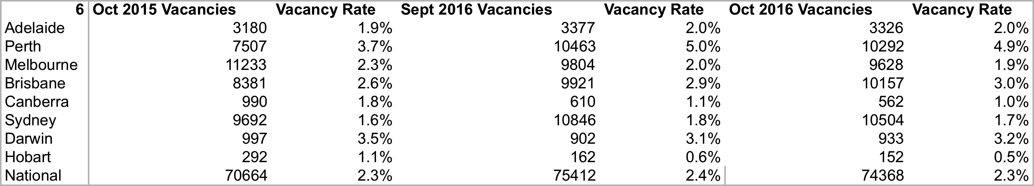
The biggest capital cities Sydney and Melbourne recorded vacancies rates of 1.7% and 1.9%, respectively, down marginally from September 2016, while Brisbane’s vacancy rate rose to 3.0%, up from 2.9%, one of only two capital cities to record a rise, along with Darwin (up to 3.2% from 3.1%).
Perth reported the highest vacancy rate at 4.9%, though it was down slightly from the previous month. Hobart had the tightest rate at just 0.5%, down from 0.6%. Year-on-year results demonstrate that the national vacancy rate is steady.
Asking rents
Sydney remains the most expensive city for rents in Australia, where asking rents for houses sitting at $738 a week and $510 for units. Asking rents have surged in Canberra, up 9.3% for houses and 8.0% for units from a year earlier. Despite a tight vacancy rate, Hobart continues to offer the most affordable rental accommodation, with houses costing just $356 a week and units averaging $297 a week.
Reflecting its high vacancy rate, Perth has recorded falls in asking rents of 11.0% for houses and 10.7% for units over the past 12 months. Yearly falls have also been posted in Darwin, with asking rents down 2.5% for houses and 3.1% for units. In Brisbane too, asking rents are down 1.8% for houses and up just 1.1% for units.
Managing Director of SQM Research, Louis Christopher, said: "Asking rents have slipped back in Brisbane as vacancy rates have continued to rise this year. At 3.0%, the rental market is finally favouring tenants and given the surge in new apartment supply, rents in Brisbane could continue to fall from here, particularly in the inner city.
“Vacancies are likely to rise in Melbourne, Brisbane and Sydney over 2017 as more new high-rise apartment developments come onto the market. However, we believe that oversupply will largely be limited to inner-city areas where apartment supply is rising the most, which will temper rental growth,” he said.
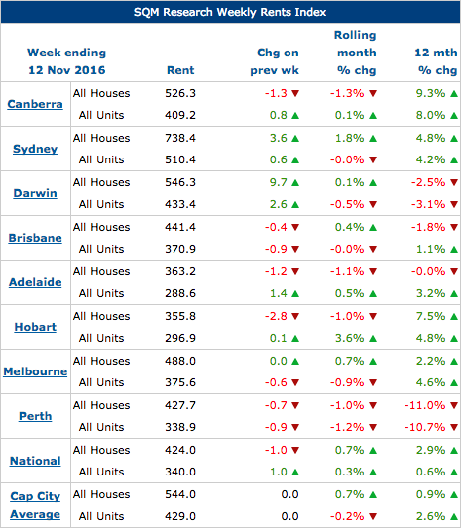

Source: www.sqmresearch.com.au
SQM’s calculations of vacancies are based on online rental listings that have been advertised for three weeks or more compared to the total number of established rental properties. SQM considers this to be a superior methodology compared to using a potentially incomplete sample of agency surveys or merely relying on raw online listings advertised. Please go to our methodology page below for more information on how SQM’s vacancies are compiled.

Key Points
- Nationally, vacancies rose edged down during October 2016, recording a rate of 2.3%.
- Perth recorded the highest vacancy rate in October 2016 of 4.9% based on 10,292 vacancies. Year-on-year, vacancy rates climbed 1.2 percentage points.
- Hobart recorded the lowest vacancy rate during October 2016 of 0.5%.
- Over the past 12 months, Perth has recorded ongoing falls in asking rents of 11.0% for houses and 10.7% for units.
- Yearly falls have also been posted in Darwin, with asking rents down 2.5% for houses and 3.1% for units
- The vacancy rate rose in Darwin in October to 3.2% from 3.1%.

www.sqmresearch.com.au
About SQM Research
SQM Research Pty Ltd is a respected Australian investment research house, specialising in providing ratings and data across all major asset classes.
For further information please contact Louis Christopher:
Louis@sqmresearch.com.au
-ENDS-

